Download here:

www.servus.at/cubic/(t)error.rar

Hardware requirements

Make sure your computer has a intel processor, it is optimised for it and otherwise it is too slow !!!!!

Minimum
Intel Pentium III 1000 GHz 256 Mb memory normal graphic card doesn’t need 3d features
Soundcard
Speakers
Usb extension (camera to computer connection)
Audio cable extension to plug soundcard to speakers
Power cables
Projector Resolution at least 800x600 don’t needs high resolution
Webcam (ideally Creative Ultra NX see picture)

Ideal
Intel Pentium IV 2000 GHz 256 Mb memory normal graphic card doesn’t need 3d features
Soundcard
Speakers
Usb extension (camera to computer connection)
Audio cable extension to plug soundcard to speakers
Power cables
Projector Resolution at least 800x600 don’t needs high resolution

Webcam (ideally Creative Ultra NX see picture)
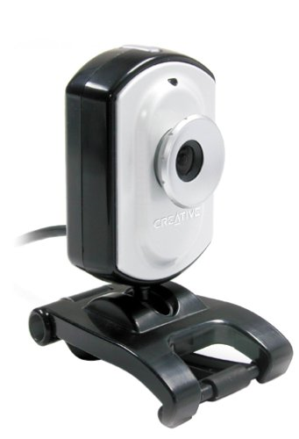

Physical Setup

Quick Start
Start the program (StartTerror.bat) and point the connected camera to the ceiling and press key ‘r’ for reference image. After that, if you move your hand in the field of View of the camera you should see the silhouette in the game, probably not really good, because it is not calibrated and automatic features are on. This is just a test that the connection with the camera works and the program works on your computer.
If you switch to fullscreen mode with key ‘f’ be sure that you have 16 bit color depth setup in your display setup of widows.
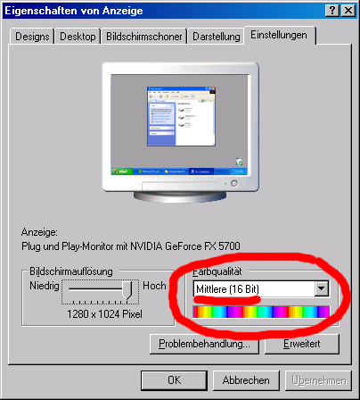

If you don’t have 16 bit color depth it is fucking slow in fullscreen.
If you switch to fullscreen and the application crashes, look at the end of this document to the troubleshooting section.

Next Steps
Position a webcam in towards a white wall. The room should have enough light and a stable light situation which means no fast changing light situations.
The USB webcam ideally (Creative Ultra NX) is positioned in the middle of wall to which is projected and mounted on the floor, the projection should not touch the camera lense, means the projection start above the floor, so no projection light touches the camera lens.
The distance of the camera to the white wall in which front the users stand depends on the used webcam. The Creative Ultra NX is suitable because it has a wide angle , so the distance can be quite short to get the height of an adult with his hands up captured. If you use another webcam be sure to have a room which is big enough because, without a wide angle lense you need a much bigger distance.
If you use lights in your setup to make the room lighter be sure it’s no focussed spotlights, or if, that they are directed to the ceiling or a wall to get an indirect light source, so no hard shadows are produced, for the installation an ambient light situation is ideal.

The camera setup
If you start the (t)error game, press the right mouse button to get the context menu, if you are in fullscreen mode, press ‘f’ before to toggle back in windowed mode. Go to:
Commands → Setup
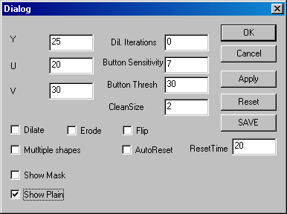

click Show Plain and press apply which gives you the live camera feed so you can adapt the color settings, exposure, etc.
Adapt these values to your light situation you have so you are satisfied with the contrast and colors, and the image is not too bright and not to dark and has enough contrast.
Switch off all automatic controls, this is very important, otherwise the camera always adapts it’s configuration, which is not wanted for the image recognition process.
If you are satisfied with the configuration of the colors and contrast and exposure, don’t worry about the focus too much.
Here you can adapt the color, exposure etc.:
Configuration → Camera Properties and you get the following window.

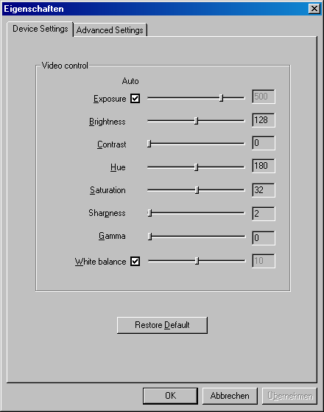

Now try to adapt the Field of view so you have the area in the captured image you want to cover, that is an adult from toe to hands up pose, and some space left and right so he can move around, and some space for walking a little bit in front and to the back. You have to experiment with this to find an adequat setup, but it’s not too difficult, but it is a big advantage if you have someone who can help you and poses for you in the image so you can say put your hands in the air, go to the left, go to the right and you adapt the postion of the camera and look on the monitor and watch if everything is in the field of view. The room should be empty so in the beginning you should ideally see a white wall in the camera view.
With the Creative Ultra NX you have a zoom, so you can zoom in if you think you are to far away.

Here you can adapt the zoom, tracking mode must be off, display mode should be normal, but you can use others, it give you different formats of the viewed image:
Configuration → Camera Properties and you get the following window.

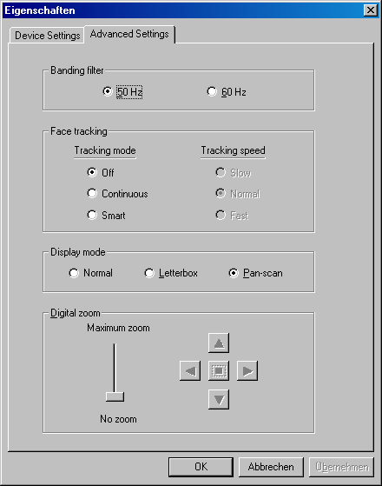

Continue with this menu and setup the image recognition parameters:
Commands → Setup

Deselect Show Plain and select Show Mask and apply, this sould give you the B/W Mask of the image recognition process.


Make sure the camera just sees the empty background with no one inside the view and press Reset, this is for getting a reference image, so the system knows how the space looks empty, if the light situation changes much you have to make sure no one is inside and press the key ‘r’ or choose Reset from the menu this means the system adapts to a new background.
If you click AutoReset and put a time from I would suggest a minute in it, the systems adapts itself over the time if no one is moving for the ResetTime, because if 60 seconds there is no motion the system can be quite sure that there is no one in the room and shoots a new reference image, this can be important for changing light situations over time, if you have windows where the sun comes in sometimes strong and sometimes gets darker.
You have to reset as well again if the position of the camera changes, means if a visitor falls over the camera or kids turn it in another direction you have to reset it’s position and press reset so it take a new reference image.
By changing the Y U V values and pressing apply you can adapt the threshold for the comparision of the reference image with the live feed good values to test are for Y (which is the intesity) 20-70 and for U and V 20-50.
The image above is a good detection it is made with a non monotone ceiling so it’s not perfect, if you have white noise in the image like this:
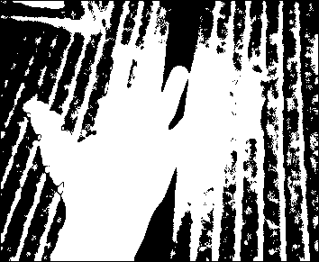
Then you have to put higher values for Y and maybe U and V as well.
If you loose things from the silhouete like this:


Your values for Y U V are too high.
As you see this is a experimentation process to make it ideal but if you have someone who poses for you then you try some values, look how the shape looks best and not too big wholes between the components (limbs) are in it then save the values with the save button. Before save deselect show mask and show plain which means the output is the game. After everything is setup fine press save so the values are next time reloaded if you start the game new.
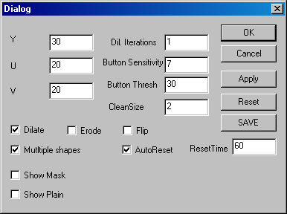

The values in the above picture are standard values which I found out work quite well.
Multiple shapes selected means more people can play the game simultaniousley, their shapes are connected, otherwise onle the biggest shape is recognized.
Autoreset means the system adapts itself.
Flip means you can flip the image if your projector can’t unlikely though.
CleanSize should be from 1 to 3 it makes the silhouette smoother and not that nervouse, if you have a value in dil Iterations you have to select dilate otherwise there happens nothing.
Button Sensitivity is for the motion buttons in the game how much you have to touch them, so they react, so is Button Thresh, these values you shouldn’t need to change.
After you setup everything as you wanted and save the parameters, you can edit the StartTerror.bat file from:

regsvr32 /S LumasProxy.ax
"(t)error"

to

regsvr32 /S LumasProxy.ax
"(t)errorFULL"

This makes the batch file automatically start the game in Fullscreen no need to press ‘f’ anymore.

The Game

If you have setup everything like explained above. The game starts like this:


If someone walks in the view of the camera or you make the ceiling test, and put your hand in the field of view you should see something like this:
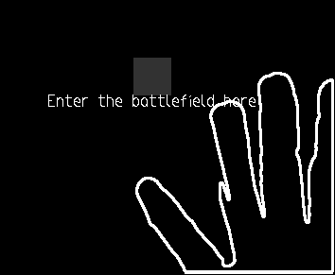

Where enter battlefield is written if you overlap the gray button, and move, then the game starts, and the screen looks like this:
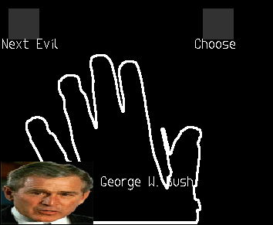

Now you can swith through a list of stereotyp evils and things connected to terror, when you move with your silhouette (normally your hand) over the Next Evil Button, so you switch further:
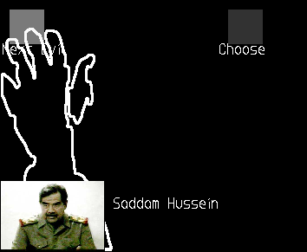

If you touch a button it gets brighter. If you have choosen your avatar, move your hand over the choose button like this. Then the game really starts and you have to avoid touching fighter planes, tanks, helicopters and submarine but you have to touch civilians (means destroy), grab dollar signs, oil pumps and civilian houses this brings you money and a good score.
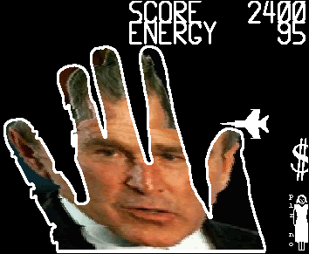

If you have been good enough you can enter the highscore press left and right arrow to switch the letter if you touch the letter you have chossen it and if you touch enter that’s your choosen name in the highscore, little bit tricky to enter names and you need patience to scroll through the alphabeth, anyway
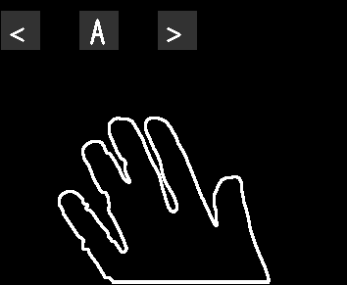
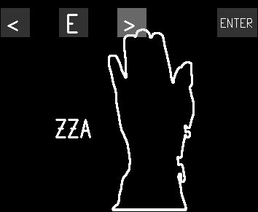

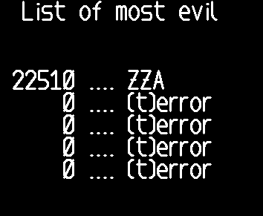

Have fun gaming, if you have questions, mail cubic@servus.at

Troubleshooting

If you get a message like this in the beginning
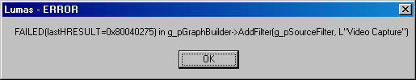

This means that the camera couldn’t be found.
Possible solutions:
Install the driver for the camera new (get it from the webpage of the producer (creative, logitech ,etc.), install it, unplug it and replug it and try again, sometimes you just have to unplug and replug the camera so windows knows a usb device is there. If it still doesn’t work when you restart the game, then try it without the USB extension if you used it before, sometimes the computers USB ports don’t give enough power so with an extension there can be problems.
Another problem could be that you haven’t started the batch file (startTerror.bat) instead you started the executable, this works if you have already started the batch file before, because there are some additional inits before the executable is started.
Be sure the camera is connected.
If you are here now and it still doesn’t work email me.

If (t)error crashes when switing to fullscreen mode, don’t worry.
I have this problem on my laptop, it hasn’t happened so far on another computer but you never know. The solution is don’t switch to from Fullscreen mode to windowed or the other way around. Setup everything in windowed mode, and the change the batch file “startTerror.bat” as described above to start with the fullscreen version. Then it works. The only thing which doesn’t work on some computers is the switching between the modes, this is some weird windows bug.

If the silhouette doesn’t look like a human anymore:
Check if the position of the camera has changed, press ‘r’ for reset when no one is in the field of view of the camera. Test again if it’s still bad quality check if the light situation is different for some reason, too dark or whatever. If someone is standing to near to the backwall his shadow can be detected as well leading to other looking silhouettes, you can tweak this with good lightning no hard shadows (soft ambient light) and the Y U V values in the setup dialog, to reduce shadow detection you have to increase Y U V values, but if you make them too high you loose things of the silhouette.

If there is something detected even if there is nothing in the room
Check camera position and press r for reset, should solve the problem

People with light clothes (colors light white and light pastell yellows ) loose parts of their body.
As the detection is against a white wall people with light colored clothes can’t be detected very well, you can compare this if you were blue in a blue box system.

Something else happens connected with (t)error ?
Mail me.

You liked the project:
Mail me

